**Business Model Canvas**

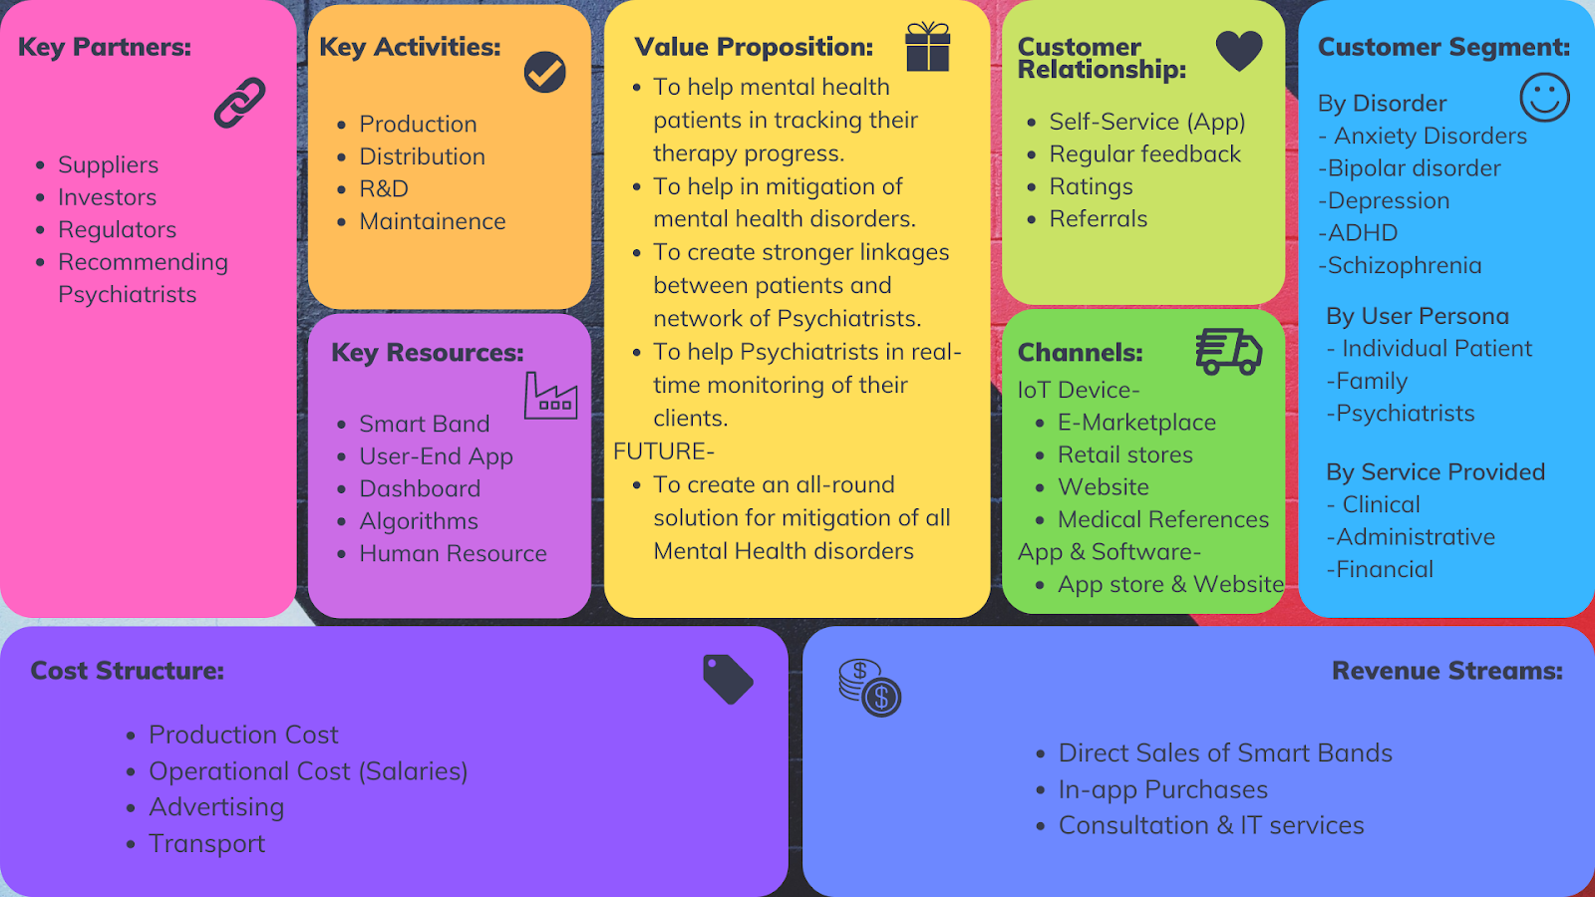

**Unique Value proposition**

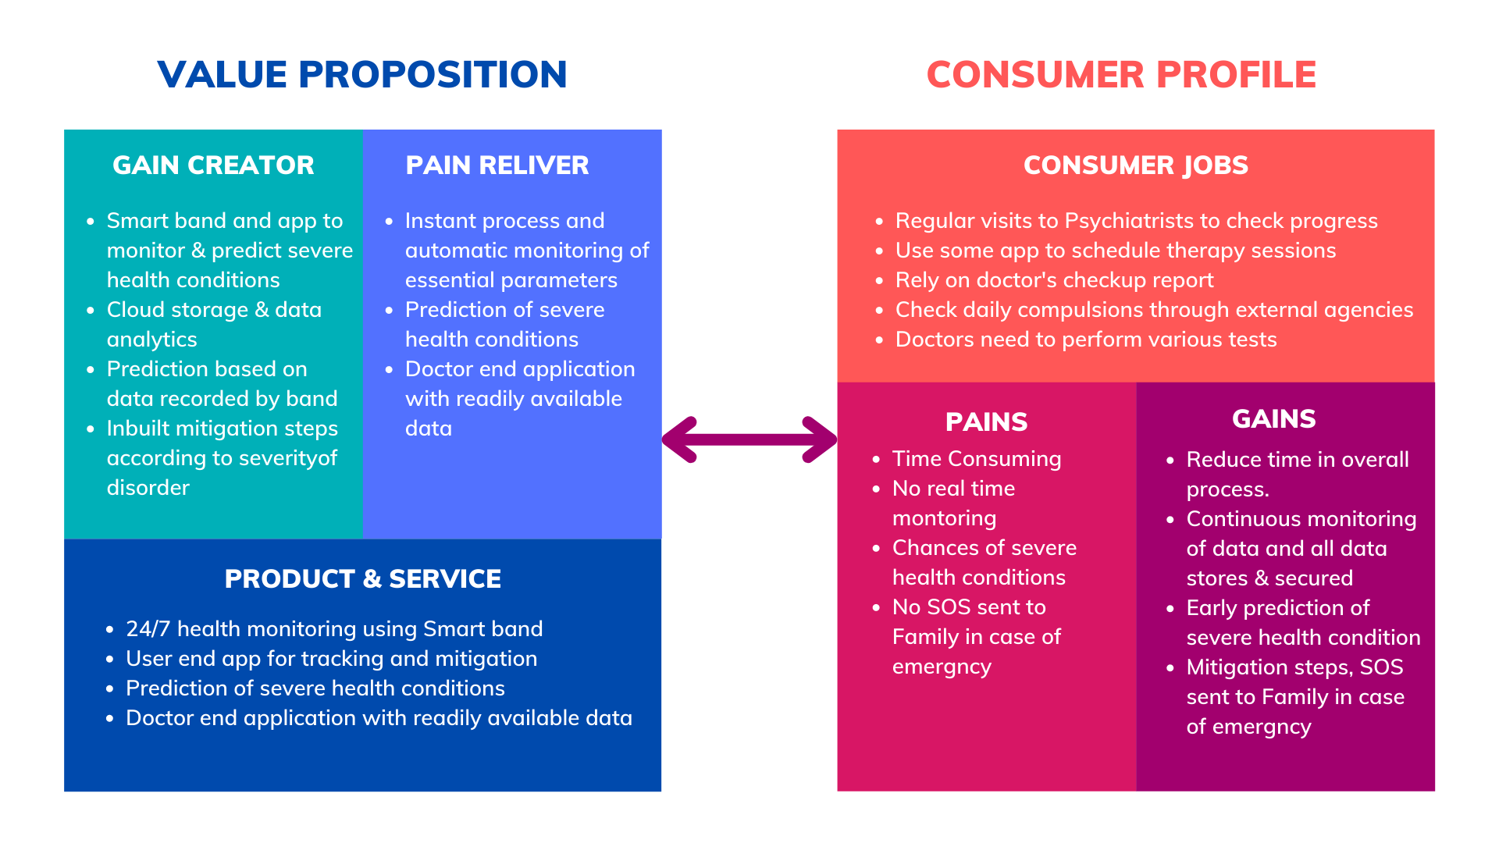

**Customer Segmentation**

As mental health is a very huge domain, we focus to help people with anxiety spectrum disorders. The product also lies in an affordable range and requires minimum internet connectivity, Hence it is meant for all sections of society

***Persona 1 (Individual Patients)-*** Unable to track progress, Cannot store daily data. Do not have a personalized treatment plan.

***Persona 2 (Family)-*** Keep track of the status of loved ones. Encourage family & community support.

***Persona 3 (Psychiatrist)-*** Need for the patient management system. Need for data during consultation.

**Customer Channels**

Distribution channels include Physical & Virtual channels as follows-

| ***Physical Channel***  This channel is only applicable for IoT devices (Smart Band).  Physical sale in Pharmacy shops.  Referrals by other patients and doctors | ***Virtual channel***  For IoT devices- InApp Purchases, Website, E-Marketplace  For App- Appstore & Website  For Software- Website |
| --- | --- |

**Customer Relationship**

The healthy relationship between users and company can be marked by-

* Regular feedback of prediction model.
* Regular feedback of App support.
* Referrals of App/Bands.
* Ratings on several websites.

**Revenue Stream**

All these customer-side business interventions will generate revenue streams for the company.

Details- <https://docs.google.com/spreadsheets/d/1tGmC5ilvg3ST7chS3FKTNZqF0qSboc8x575JbDMljg8/edit?usp=sharing>

**Key Activities**

This includes a crucial part of the Business Value chain. The main operation of the Business is concerned with the Production, Distribution of smart devices, advertising, and maintenance.

Frequent updates in App and Software, Database management, Other business legalities.

Giving impetus to Research and Development for the launch of new products/services. Also taking its due approval from BIS or any other certifying agency.

**Key Resources**

Our key resources include all the essential files/codes/product from the origination to the termination of the value chain. Human Capital.

**Key Partners**

These include regulators those who approve our products, Psychiatrists who recommend our products, Investors as well as suppliers

**Cost Structure**